

Submitted by : Spogmai Jan

Roll no : 2430 - 0081

Submitted to : Sir Bilal Dar

Subject : Digital Logic Design Lab

**Lab task 04**

**Experiment#1:**

**Demorgan’s Law 1st Law:**

|  |  |  |  |  |
| --- | --- | --- | --- | --- |
| **X** | **Y** | **X+Y** | (X+Y)` | X`.Y` |
| 0 | 0 | 0 | 1 | 1 |
| 0 | 1 | 1 | 0 | 0 |
| 1 | 0 | 1 | 0 | 0 |
| 1 | 1 | 1 | 0 | 0 |

**Experiment#2:**

**Demorgan’s Law 2nd Law:**

|  |  |  |  |
| --- | --- | --- | --- |
| X | Y | (X.Y)` | X`+Y` |
| 0 | 0 | 1 | 1 |
| 0 | 1 | 1 | 1 |
| 1 | 0 | 1 | 1 |
| 1 | 1 | 0 | 0 |

Hence prove : (x.y)`= x`+ y`

**Experiment#3:**

**a)Form 1: x+(x.y)=x**

|  |  |  |  |
| --- | --- | --- | --- |
| x | y | x.y | x +(x.y)=x |
| 0 | 0 | 0 | 0 |
| 0 | 1 | 0 | 0 |
| 1 | 0 | 0 | 1 |
| 1 | 1 | 1 | 1 |

**b)Form 2: x.(x+y)=x**

|  |  |  |  |
| --- | --- | --- | --- |
| **x** | **y** | **x+y** | **x.(x+y)=x** |
| **0** | **0** | **0** | **0** |
| **0** | **1** | **1** | **0** |
| **1** | **0** | **1** | **1** |
| **1** | **1** | **1** | **1** |

**Experiment#4:**

**Z=(A.B)`+(A+C`).B**

|  |  |  |  |  |  |  |  |  |
| --- | --- | --- | --- | --- | --- | --- | --- | --- |
| **A** | **B** | **C** | **A.B** | **(A.B)`** | **C`** | **A+C`** | **(A+C)`.B** | **(A.B)`+(A+C)`.B** |
| **0** | **0** | **0** | **0** | **1** | **1** | **1** | **0** | **1** |
| **0** | **0** | **1** | **0** | **1** | **0** | **0** | **0** | **1** |
| **0** | **1** | **0** | **0** | **1** | **1** | **1** | **1** | **1** |
| **0** | **1** | **1** | **0** | **1** | **0** | **0** | **0** | **1** |
| **1** | **0** | **0** | **0** | **1** | **1** | **1** | **0** | **1** |
| **1** | **0** | **1** | **0** | **1** | **0** | **1** | **0** | **1** |
| **1** | **1** | **0** | **1** | **0** | **1** | **1** | **1** | **1** |
| **1** | **1** | **1** | **1** | **0** | **0** | **1** | **1** | **1** |

**(A.B)**

**Switch 0 ON Swictch 1 Off Led 0 is on**

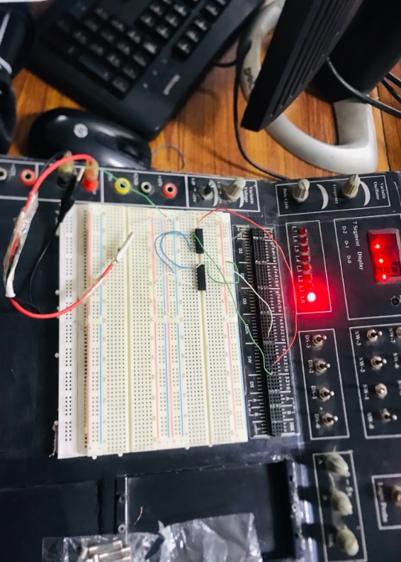

**Switch 0 On Switch 1 Off Led 0 is On**

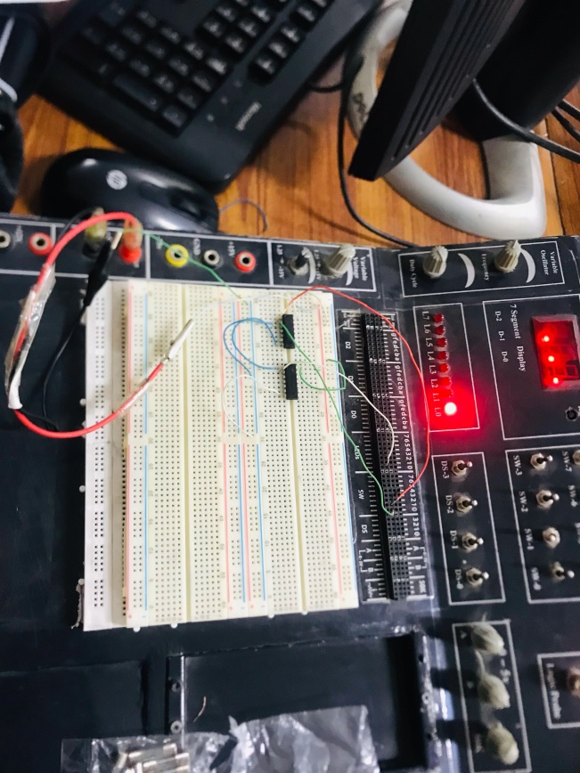

**Switch 0 off Switch 1 Off is Led 0 On**

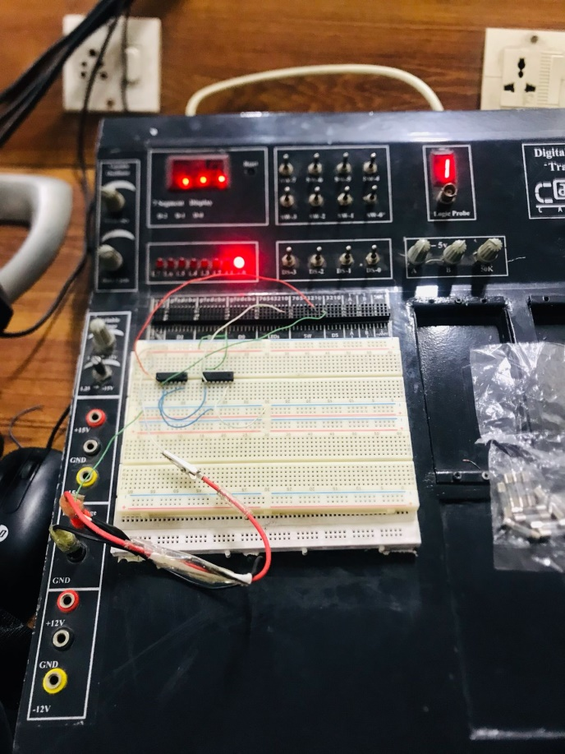

**Switch 0 Off Switch 1 Off Led Off**

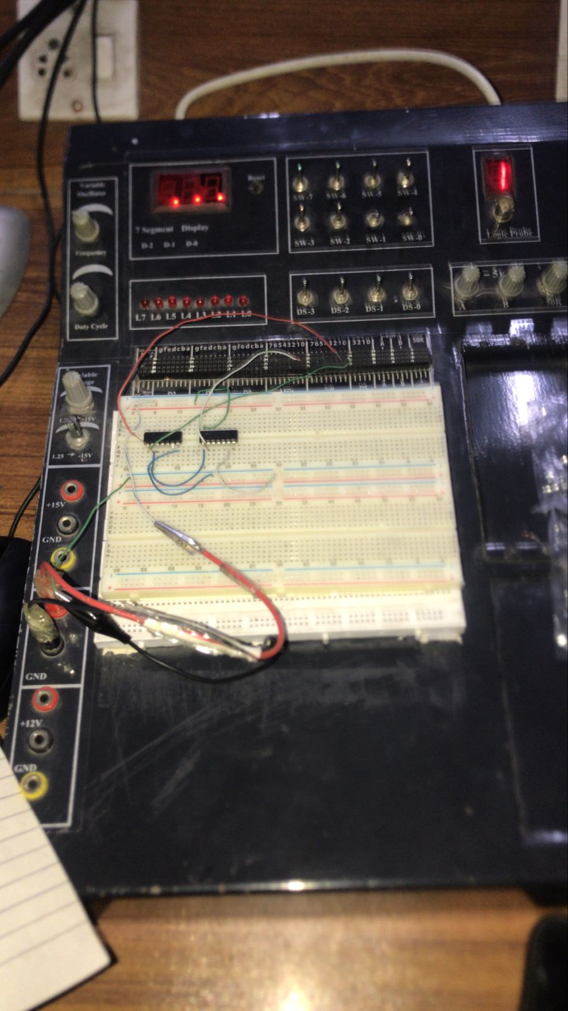

**A+C`**

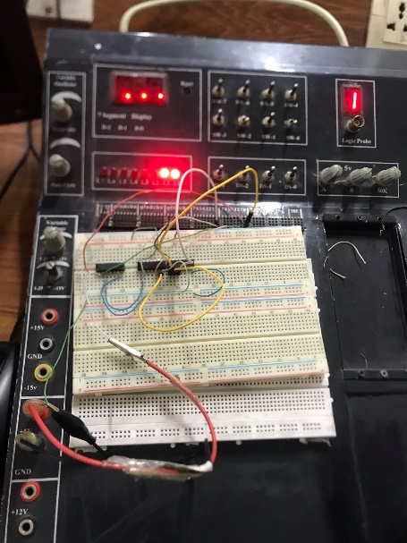

**Switch 0 On Switch 2 Off Led 1 On**

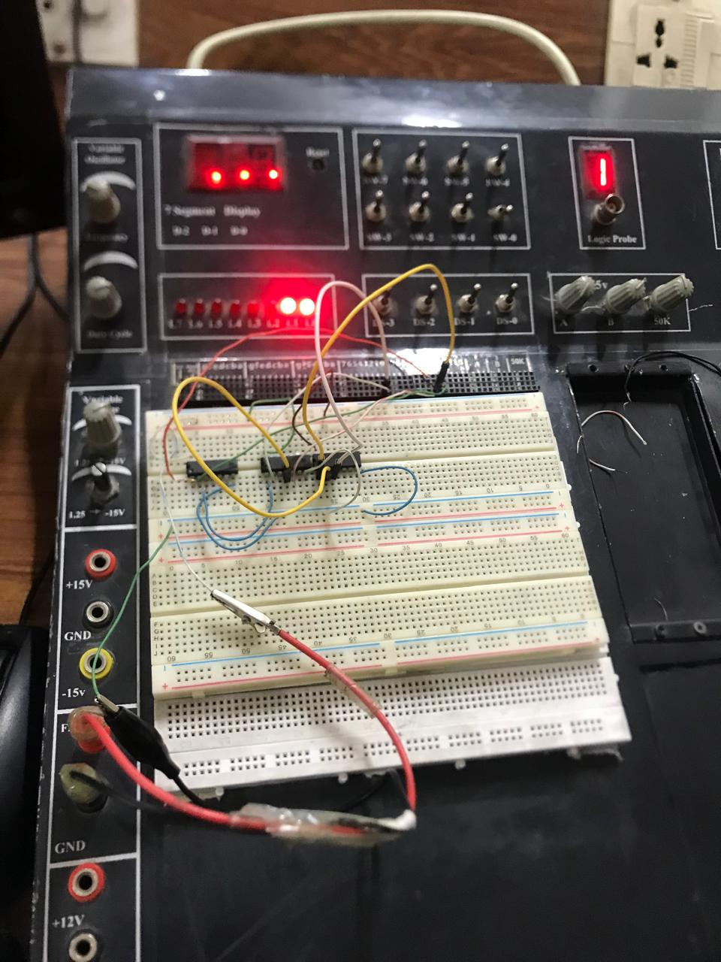

**(A.B)`+(A+C`).B**



